



**Sudoku Solver**

**Visualizer**

The Sudoku Solver Visualizer is an interactive Java application designed to

solve Sudoku puzzles while providing a real-time visual representation of

the solving process. This project aims to demonstrate the backtracking

algorithm, showcase Java Swing's capabilities for GUI development, and

offer insights into Sudoku solving techniques.

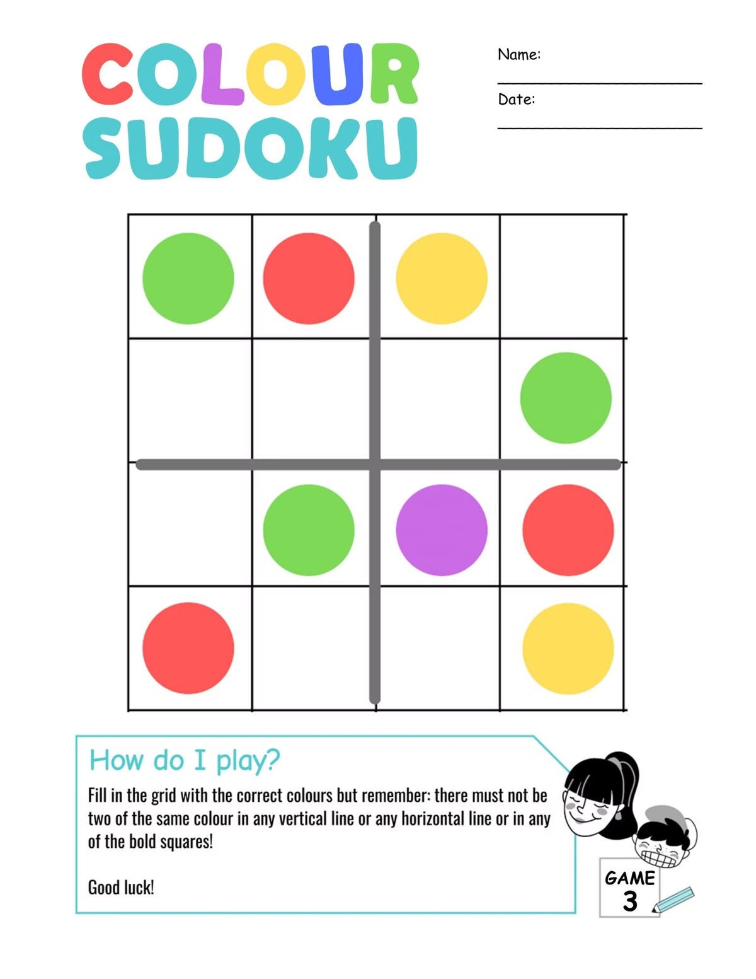

**Project Objectives**



**1**

**Algorithmic Demonstration**

Visualizes the backtracking algorithm to provide an intuitive

understanding of its workings.



**2**

**Interactive Visualization**

Users can watch the solving process with color-coded feedback for

placed numbers (cyan) and backtracked attempts (red).



**3**

**Java Swing Utilization**

Demonstrates creating a grid-based layout, using JLabels, and

updating GUI components in real-time.



**4**

**Problem-Solving Insight**

Offers insight into logical steps required to solve complex Sudoku

puzzles.



**Key Features**

**Interactive GUI**

Built with Java Swing, ensuring

platform independence. Uses

GridLayout for a 9x9 grid, with

JLabels representing each cell.

**Real-Time Visualization**

Users can observe the solving

process, including number

placements and backtracking.

Color-coding: Cyan for successfully

placed numbers, Red for

backtracked cells, Light Gray for

initial state and final solution.

**Backtracking Algorithm**

Efficient backtracking algorithm

explores potential solutions and

backtracks when encountering

invalid states. Offers a clear view of

the decision-making process

during puzzle solving.



**Technical Implementation**

Programming Language and

Framework

Java, Java Swing

Core Components

Sudoku Solver Class, GUI

Elements

Algorithm Details

isSafe Method, findSolution

Method, solveSudoku Method

Visualization

Color Coding, Real-Time

Updates

Data Structures

2

D Arrays, Predefined Puzzles



**User Interface**

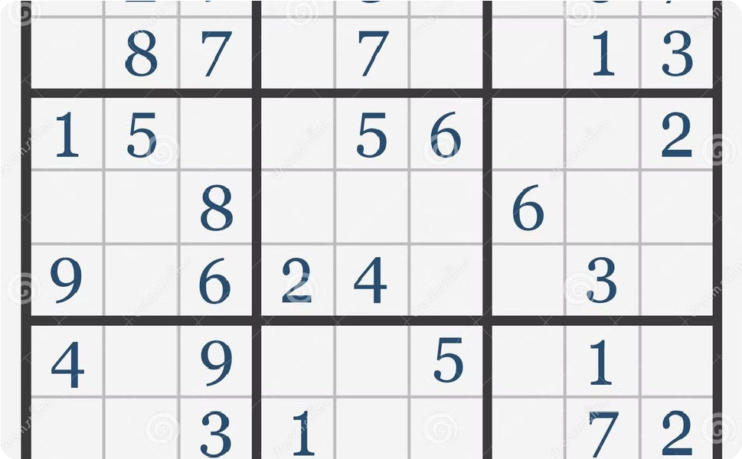

**Main Window**

JFrame Configuration: 500x500

pixels, GridLayout(9, 9), and

JFrame.EXIT_ON_CLOSE. Set to

visible after all components are

added.

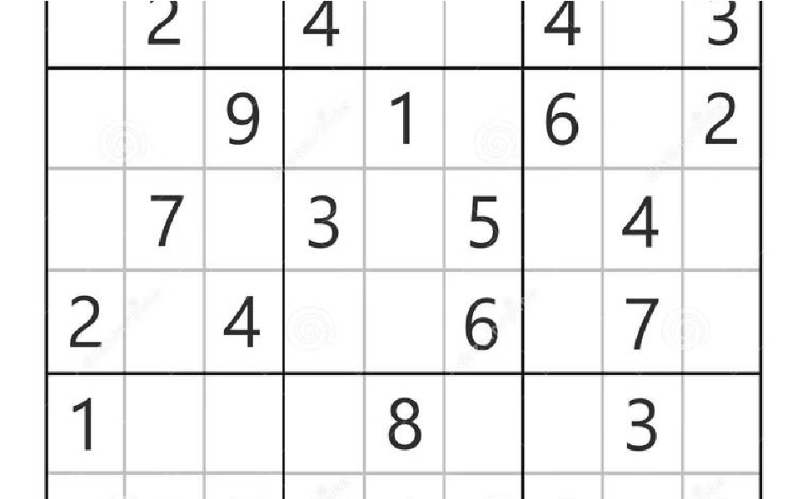

**Sudoku Grid**

Each cell represented by a JLabel.

Custom borders to visually separate

3

x3 subgrids.

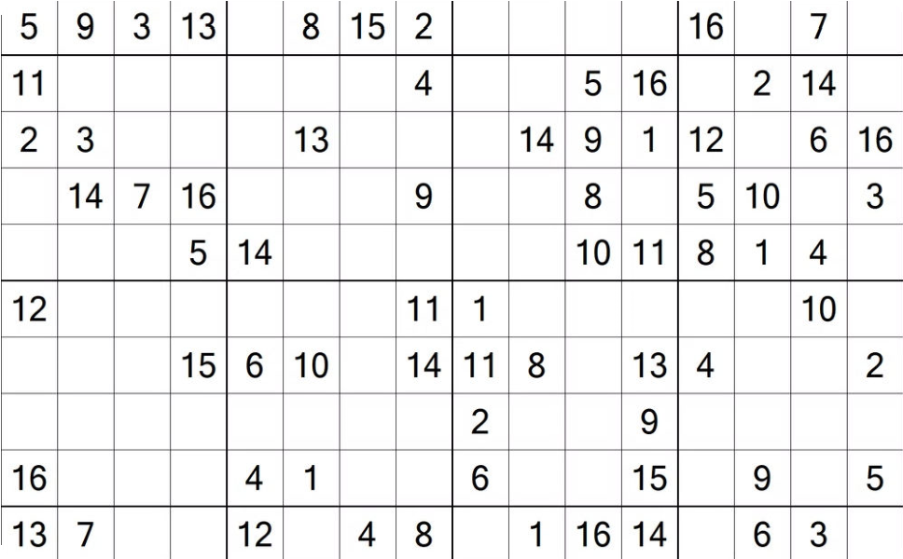

**Dynamic Updates**

Real-Time Visualization: Updates for

each cell change. Backtracking

Visualization: Red cells indicate

backtracked attempts.



**Performance Considerations**



**1**

**Algorithm Efficiency**

Efficient for most Sudoku puzzles with pruning techniques

and early termination.



**2**

**GUI Update Frequency**

Potential performance issues for very fast solves.



**3**

**Scalability**

Currently handles only 9x9 grids. Static nature limits solving

multiple puzzles simultaneously.

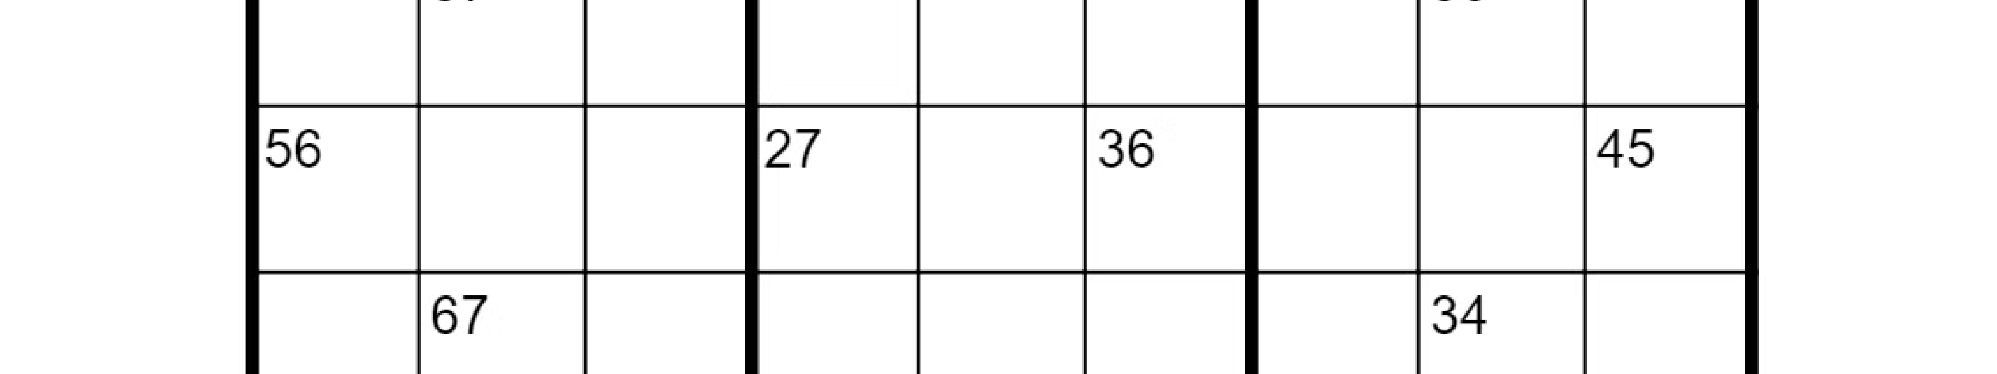

**Future Enhancements**



**User Input for Custom Puzzles**

Input Mechanism: Text input field, clickable grid, or

file upload. Input Validation: Ensure valid Sudoku

grids.



**Difficulty Levels**

Puzzle Generation: Generate puzzles of varying

difficulties. Difficulty Rating: Rate and display puzzle

difficulties.



**Adjustable Visualization Speed**

Speed Control: Slider or buttons for adjusting

visualization speed. Pause and Resume: Functionality

to control the solving process.



**Step-by-Step Explanation**

Textual Descriptions: Provide written explanations

for each step. Explanation Panel: Display

explanations alongside the visual grid.

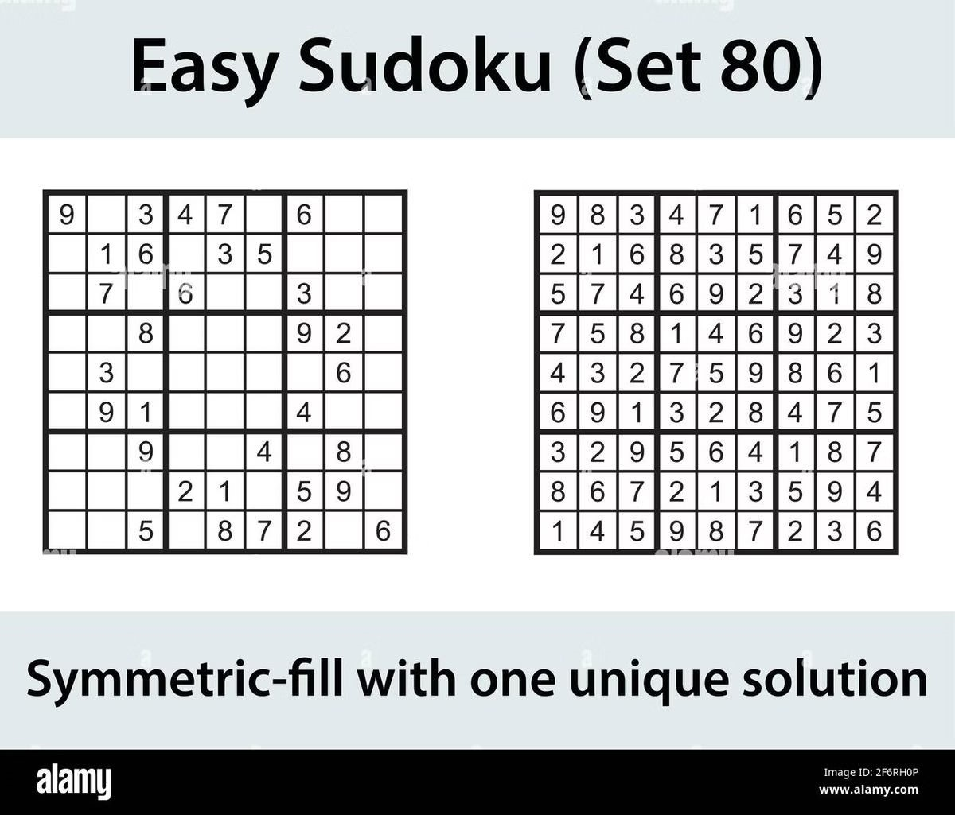

**Conclusion**



**Achievement of Project Goals**

Solving Capability: Efficiently solves standard 9x9 Sudoku puzzles.

Visualization Effectiveness: Provides a clear, real-time view of the solving

process. Educational Value: Serves as a powerful tool for demonstrating

algorithmic concepts.



**Future Potential**

Educational Platform: Evolve into a comprehensive tool for teaching

algorithms. Sudoku Training Tool: Enhance with user-solving capabilities

and hints. Algorithm Comparison Framework: Compare different solving

algorithms visually.